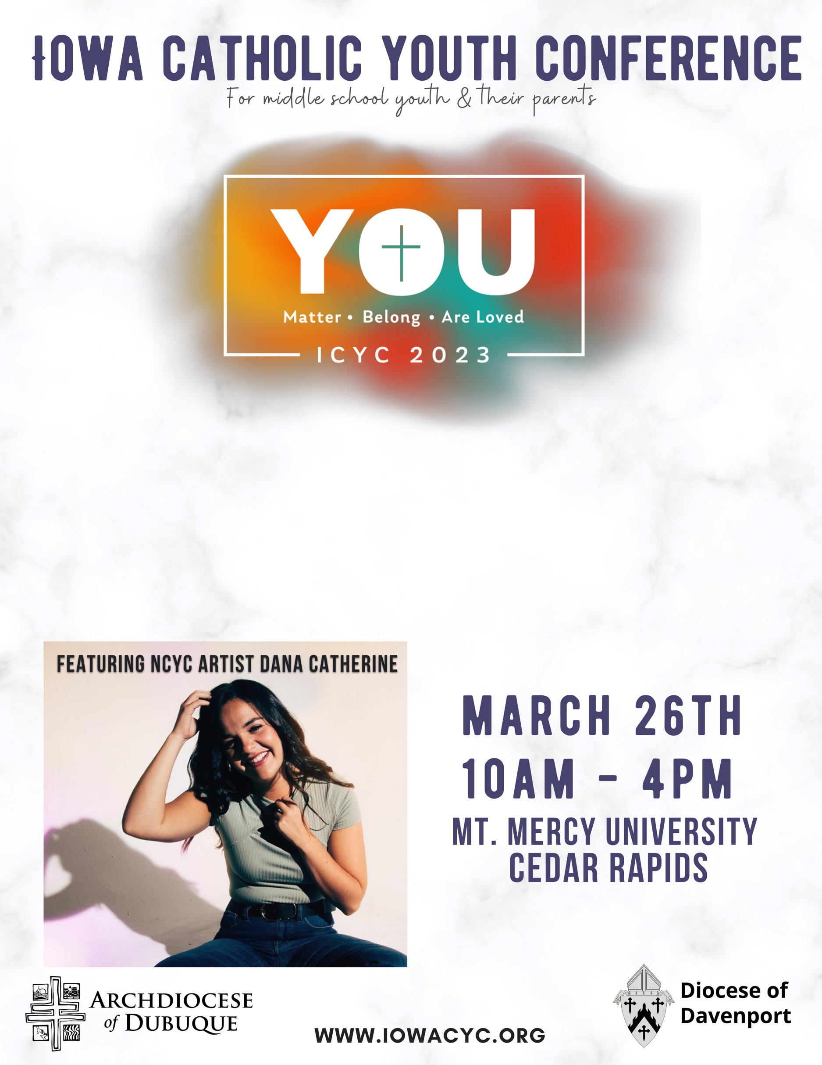
You are invited to join our parish for a group trip to Mount Mercy University for the Iowa Catholic Youth Conference. This event is for Middle School youth in grades 6-8. Parents are welcome to come along!

Each youth and adult participant must complete the Event Liability Waiver.
The cost is [Enter your price here] per person and should be paid when registering.

To register your child (and yourself) for this event, please complete the registration by [enter registration method here].

If you have any question, please contact [enter your name and information here].

